Mazama 2018: June 23-24 Marblemount-to-Mazama (and back)
RIDE INSTRUCTIONS

To get to Marblemount from Seattle: 2-hour drive
Two ways to get to Marblemount:
- Take I-5 to Arlington. At Hwy. 530, go east. At Darrington, continue north on Hwy 530, then turn east on Hwy 20 at Rockport. Continue east to Marblemount. 100 mi., 1-3/4 hr. from Seattle.
- Go north on I-5 to Mt. Vernon, then go east on Hwy 20 to Marblemount. 110 mi., 2 hr. from Seattle.

Start Point: Marblemount Community Hall (just past the 90* bend in the road on the left hand side)
- Arrive between 7:00 and 7:45 a.m.
- Mandatory Meeting at 8:00 am
- Park as directed
- Check in with Larry and Janice; SIGN WAIVER
- Pay $5 fee to leave vehicle overnight (bring exact change!) Event staff will direct you where to park.
- FREE WiFi at this location if you need it!
- Load bags onto Sag vehicles
- Riders to leave no later than 8:30 a.m.

To get to the Marblemount Community Hall: As you enter the town of Marblemount the Community Center is just past the 90* degree turn on the left hand side. We will be using the parking lot in the rear of the building. There is a $5.00/per vehicle charge for parking.

Sag Support
Sag support will be provided to carry your overnight bag to Mazama and back again on Sunday. Space for baggage is limited so please pack conservatively. ONE bag per participant. Please have your bag loaded in a sag vehicle no later than 8:15 a.m.

The sag vehicles will also be available to pick you up in case of mechanical or physical problems. However, don't plan on fetching anything from a sag vehicle during the ride. You should carry whatever you expect to need.

On Route Water & Food
Water: We will provide plenty of water along the route.

Lunch: Lunch provided both days.

Saturday lunch will be 35 miles into the ride, at CANYON CREEK TRAILHEAD – approx. 9.4 miles beyond the Diablo Overlook.

Sunday lunch will be 48 miles into the ride (mostly downhill) at the DIABLE Overlook.

There are toilets at both of these locations.

Menu: Turkey/Ham and PBJ sandwiches, chips, cookies, Gatorade, fruit, pretzels, water and soda.

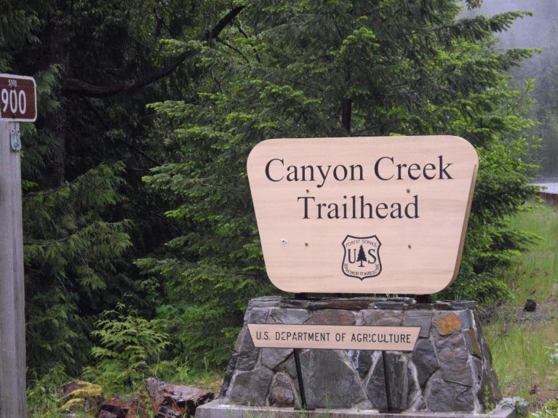
LUNCH STOP – SATURDAY – MP 141.5

What To Bring
- REQUIRED: Rain gear and cold-weather bike gear
- Sunscreen
- Your bike!
- REQUIRED Helmet
- Bike shoes (double check to be sure you’ve got them!) Now check again – are they there?
- Oh yeah, don’t forget your front wheel.
- Your favorite on-the-bike food and drink potions (see On Route Water & Food we provide)
- Swimsuit (for the hot tub and pool at Mazama Country Inn on Saturday)
- Comfortable clothes and personal items for after the ride on Saturday
- $5 bill for parking fee (exact change is really, really appreciated).

Important Mile Markers
NOTE: Bathroom facilities are available at nearly all of the marked “Trailheads”, but there is no water other than what we carry except at Newhalem. Plan accordingly.

Ride Start: MP 106.3 Community Ctr.
Newhalem MP 120 (bathrooms/groceries)
Restrooms 3 between Newhalem & Lunch
LUNCH Day 1 (on left) MP 141.5 (Canyon Creek TH)
LUNCH Day 2 MP 131.5 Diablo overlook
Water Drop Day 1 MP 151 (Easy Pass TH)
Rainy Pass MP 157.5
Bathrooms MP 159.6 (bottom of pass)
Washington Pass: MP 162.5
Water Drop Day 2: MP 168.4 (Cutthroat TH)
Mazama: MP 179.3 (left turn to Inn)

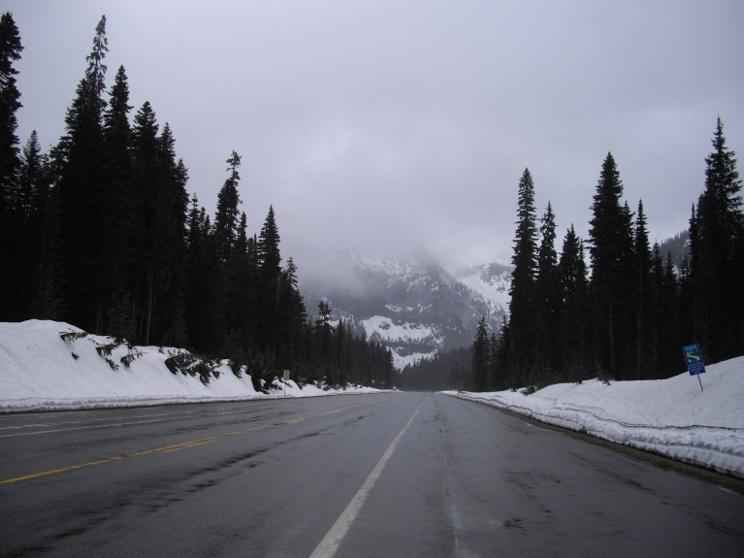

View Eastbound – Washington Pass 6/18/2011

Cancelation Policy

May 1, 2018 or earlier a registered rider is eligible for a 100% refund of their registration (less fees).

No refund will be given for any reason, medical or otherwise after May 1, 2018.

Due to lodging arrangements transfers need to be approved by the event coordinators. ALL ROOMS ARE SHARED!

Route

The route from Marblemount to the Mazama Country Inn is simple - head east on Hwy Route 20 for about 75 miles. On Saturday, we climb about 6800 feet. On Sunday, we climb 4800 feet. The Inn is on the left shortly after finishing the descent on the east side of Washington Pass (look for the road sign). The weather is often cold (and sometimes wet!) at the top of Washington and Rainy Passes, regardless of the weather forecast.

Be prepared! You MUST bring warm clothing and raingear...

Mazama Country Inn

CHECK IN WHEN YOU ARRIVE AT THE INN

Dinner and breakfast are included in your registration fee. In addition, there will be snacks, soft drinks, and beer and wine waiting for us at the Inn when we arrive on Saturday afternoon. You will receive 1 (one) complementary drink of your choice upon check in.

Please no charges to your rooms. If there are they will need to be closed out before you leave Sunday morning.

Important! No personal alcohol in public areas: In the past, riders have brought private coolers of beer and bottles of wine to enjoy at the Inn after the ride. Apparently, this practice violates the Inn’s liquor license, so we can’t have private alcoholic beverages in public areas around Mazama Country Inn. You may purchase Alcohol directly from the Mazama Inn.

Saturday Dinner: 6:30 p.m.

Sunday Breakfast: 7:00 a.m.

Vegetarian meals: There will be vegetarian food options at all meals.

If you need to contact the Mazama Country Inn, their phone number is 800-843-7951. Cell phone coverage between Marblemount and Mazama is spotty at best. They do have a phone where you can make calls using your calling card.

See you in Marblemount!

Larry and Janice Sepulveda
RCC Mazama Ride Coordinator
lspudly@hotmail.com or Janice_letteer@hotmail.com
(cell) 206.696.3118 or (cell) 360.269.7510

Thanks to Tom Shafer for preparing this ride profile for us.

On Saturday, we climb about 6800 feet.
On Sunday, we climb about 4800 feet.

