Celebrating 34th year – 2 Days, 150 Miles, and 11,600 ft. of Climbing

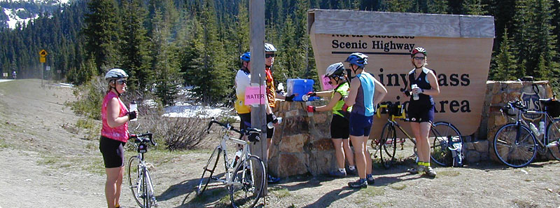
This year’s annual Mazama Ride will begin in Marblemount on Saturday. We will ride 75+ miles on the North Cascades Highway, climbing a total of 6800 feet over Rainy and Washington Passes, descending into the gorgeous Methow valley, ending our day at the Mazama Country Inn. After an overnight at the Mazama Country Inn, we head back west Sunday morning climbing a total of 4800 feet finishing back at the start!
Registration Information
Mazama cost is $160 per person (shared bed) or $210 per person (*single bed) as an RCC member. If you are not an RCC member cost is $165 & $215. Please considering signing up today and you would save $5 off of your registration fee! Your registration fee covers sag support, water along the course, on-route lunches Saturday and Sunday, lodging (ALL rooms are shared) Saturday night at Mazama Country Inn, a snack and beverages on Saturday afternoon, family-style dinner Saturday evening, and buffet-style breakfast Sunday morning. We carry your bags, so all you have to do is ride!
*Please note that all rooms are shared – the single option is only regarding the bed space

Cancellation Policy: All cancellations prior to May 1 will get a full refund minus any web site registration fees. After May 1 there will be no refunds due to the nature of confirming sleeping arraignments. Any transfers of registrations will require approved from the Mazama event directors.

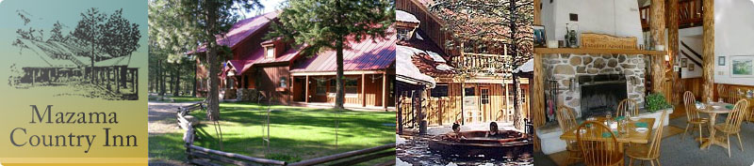
For more information please email mazama@redmondcyclingclub.org.

